Zika outbreak started and also caused fear and misinformation to spread. In the recent years, citizen sensing has picked up greatly with the rise of mobile device popularity, as well as with the rise in social media sites such as Facebook and Twitter. The idea with citizen sensing is that citizens play the role of sensors in the environment providing information regarding healthcare issues such as isease outbreaks in case of Zika . Zika virus (ZIKV) epidemic in the Americas is unprecedented. ZIKV-infected pregnancy could be complicated with  
fetal microcephaly and long-term developmental disability.[1,2] Epidemiologic evidences suggested that ZIKV might cause GuillainBarré syndrome.[3] The World Health Organization (WHO) declared it a Public Health Emergency of International Concern (PHEIC) on February 1, 2016.[4]  
As of 2015, Twitter had 320 million monthly active users, supporting >35 languages.[5] English, Spanish, and Portuguese are among  
the top 10 languages used on Twitter.[6]  
Our study aims to provide baseline data for future ZIKV-related  
Twitter health communication. We report the incidence trends of  
ZIKV-related Twitter data and our content analysis of a crosssectional sample of ZIKV-related English Tweets

**1.2 LITERATURE REVIEW**

Zika virus is a mosquito-borne flavivirus that was first identified in Uganda in 1947 in monkeys through a network that monitored yellow fever. It was later identified in humans in 1952 in Uganda and the United Republic of Tanzania. Outbreaks of Zika virus disease have been recorded in Africa, the Americas, Asia and the Pacific. From the 1960s to 1980s, human infections were found across Africa and Asia, typically accompanied by mild illness. The first large outbreak of disease caused by Zika infection was reported from the Island of Yap (Federated States of Micronesia) in 2007. In July 2015 Brazil reported an association between Zika virus infection and Guillain-Barré syndrome. In October 2015 Brazil reported an association between Zika virus infection and microcephaly.[7]

Zika belongs to the Flaviviridae family of viruses [8]. This family contains a few arboviruses that are very important clinically, such as dengue virus, yellow fever virus, West Nile Virus, tick-borne encephalitis virus, and Japanese encephalitis virus [8]. Prior to 2007 there had only been 14 confirmed cases of Zika; however, many people do not even realize they are sick from Zika, let alone need to go to the hospital and death due to Zika is extremely rare [9]. The Zika virus usually only causes mild symptoms such as a headache, rash, fever, conjunctivitis, and joint pain which can last from a few days to a week after being infected. These symptoms are similar to Dengue and Chikungunya, which are also spread by the same mosquito as Zika. The incubation period is unknown at this time but suspected to be a few days to a week. The virus typically remains in the blood for about a week, but has been found later in some people. People at risk of getting Zika include people that travel or live in an area where Zika has been found and has been bit by a mosquito, and partners of men that have traveled to an area with the Zika virus. In the next several months the countries with active cases is expected to increase [9].

Twitter, being one of the very few social media platforms which is used in  
everyday life in tech-enabled society of 21st century. It is an area where we can  
abstract data regarding Zika Virus Outbreak from Twitter using keywords. By  
analysing data from thousands of tweets regarding Zika Virus outbreak we can  
be assured about people's awareness about Zika Virus.  
Aedes mosquito, the name which got ill-famous in 2015 because of the virus  
it spread which is immedicable and irremediable. The virus named is ZIKA  
because of its first appearance in zika forest of Uganda.  
By 2016, it had reached Asia, Africa and America and by the recent news, it has  
reached in India in the initials of 2017.  
The ZIKA Virus has been portrayed as a mysterious illness with devastating  
effect and rightly or wrongly proclaimed as the next major global health crisis

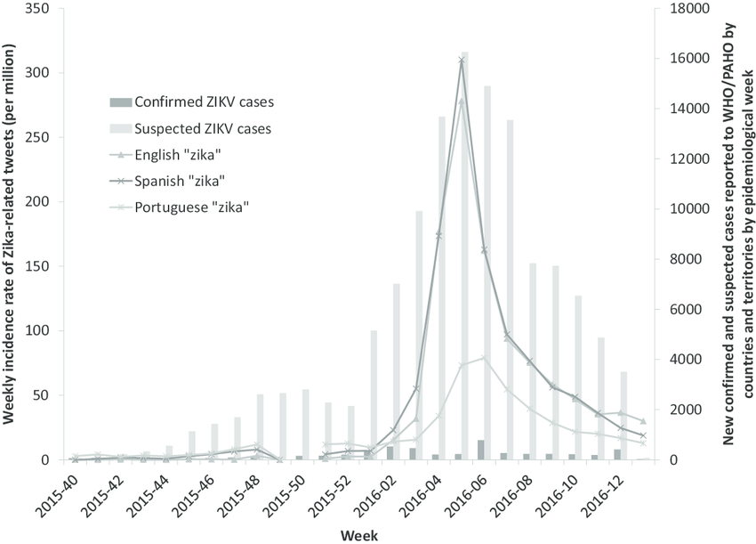

**Fig 1.** Weekly incidence rate of Zika-related Tweets (per million) by language (English, Spanish, and Portuguese) (left *y*-axis) and the number of new confirmed and suspected cases  
reported to the WHO/PAHO by countries and territories (right *y*-axis) by epidemiologic week, October 2015-March 2016. Our Twitter data were based on the 1% streaming Application Programming Interface data from May 1, 2015-April 2, 2016. Data were missing on the following dates because of server breakdown: May 20-28, 201 5; June 15-18, 2015;  
July 2-5, 2015; July 31-August 1, 2015; August 29-September 3, 2015; November 8, 2015; November 24, 2015; December 1-7, 2015; December 9-19, 2015; December 22-23, 2015;  
December 30, 2015-January 4, 2016; and January 22, 2016. Weekly ZIKV-related Twitter incidence rates for weeks 48 and 49 (2015) were based on data from 2 days (November  
29-30) and 1 day (December 8, 2015) respectively. Because of the missing data, cautious interpretation is warranted. Epidemiologic data were manually extracted from PAHO/WHO  
(http://ais.paho.org/phip/viz/ed_zika_epicurve.asp). *PAHO*, Pan American Health Organization; *WHO*, World H